**Project Design Phase-II**

**Data Flow Diagram & User Stories**

|  |  |
| --- | --- |
| Date | 29/JUN/2025 |
| Team ID | LTVIP2025TMID32012 |
| Project Name | Citizen-ai |
| Maximum Marks | 4 MARKS |

**Data Flow Diagrams:**

DFD Level 0 (Industry Standard):

**FLOW CHART:**

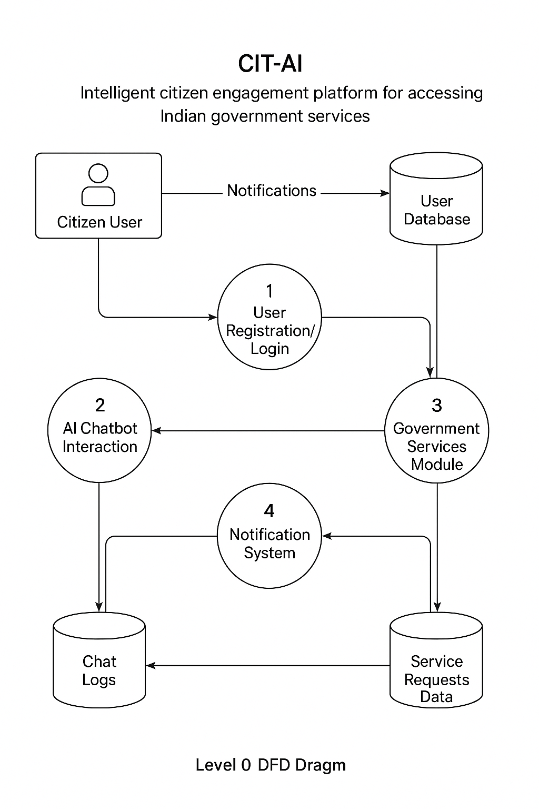

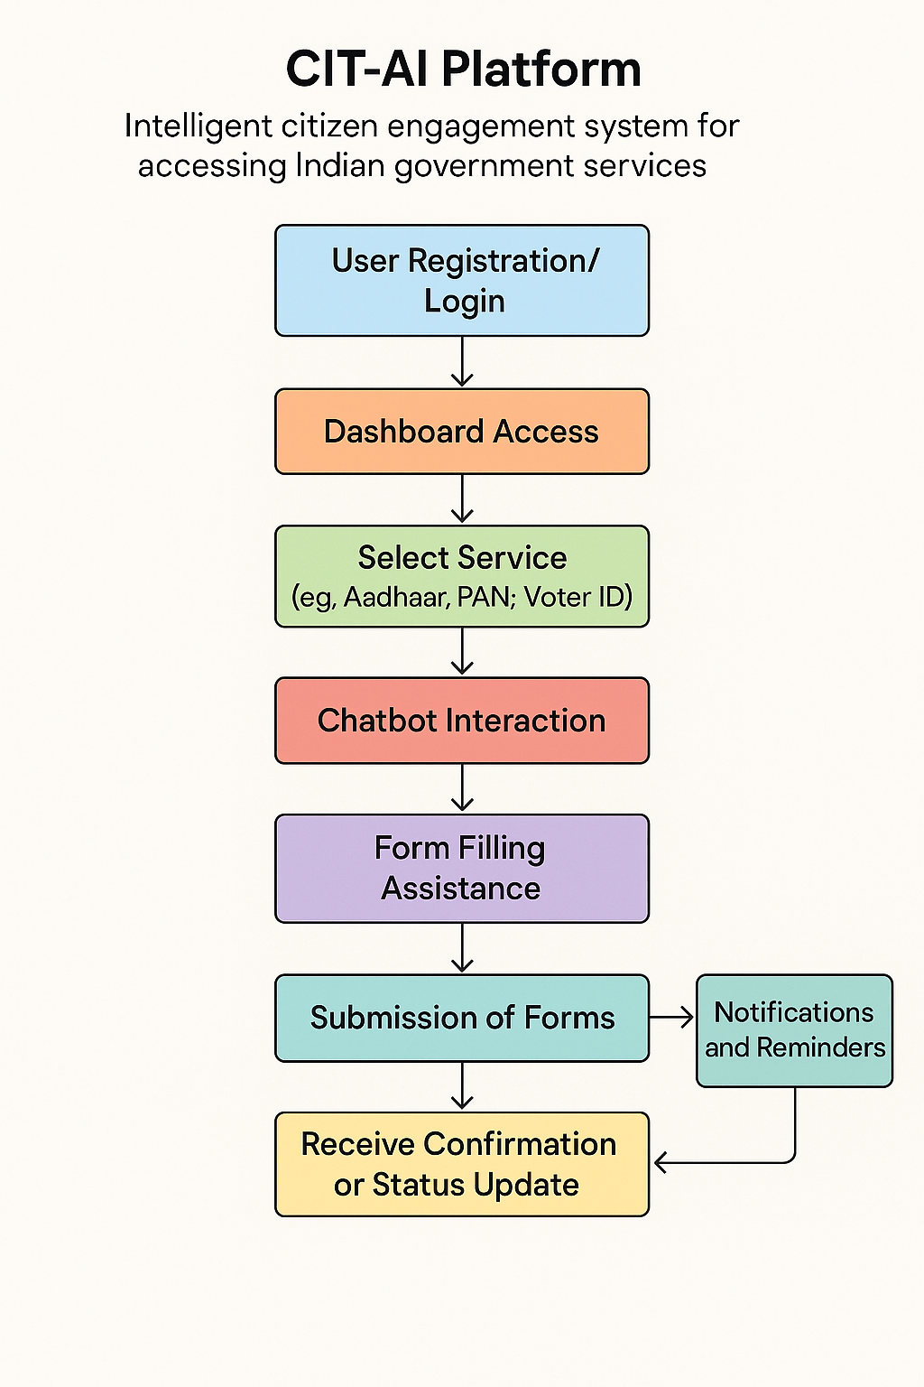

**User Stories:**

| **User Type** | **Functional Requirement (Epic)** | **User Story Number** | **User Story / Task** | **Acceptance Criteria** | **Priority** | **Release** |
| --- | --- | --- | --- | --- | --- | --- |
| Customer (Mobile user) | Registration | USN-1 | As a user, I can register for the application by entering my email, password, and confirming my password. | I can access my account/dashboard. | High | Sprint-1 |
|  |  | USN-2 | As a user, I will receive a confirmation email once I have registered for the application. | I receive email and can click confirm. | High | Sprint-1 |
|  |  | USN-3 | As a user, I can register for the application through Facebook. | I can register & access the dashboard with Facebook Login. | Low | Sprint-2 |
|  |  | USN-4 | As a user, I can register for the application through Gmail. | I can register & access the dashboard with Gmail Login. | Medium | Sprint-1 |
|  | Login | USN-5 | As a user, I can log into the application by entering email & password. | I successfully log in and reach the dashboard. | High | Sprint-1 |
|  | Dashboard | USN-6 | As a user, I can view and select government services like Aadhaar, PAN, Voter ID. | Services load without errors. | High | Sprint-1 |
|  | Chatbot Interaction | USN-7 | As a user, I can chat in my language to get help with government services. | Chatbot responds correctly in chosen language. | High | Sprint-2 |
|  | Voice Interaction | USN-8 | As a user, I can speak queries to the chatbot and hear voice responses. | Voice is recognized and TTS responds correctly. | Medium | Sprint-3 |
| Customer (Web user) | Form Automation | USN-9 | As a user, I can fill and submit government forms through the web portal. | Forms submit successfully and save to database. | High | Sprint-2 |
|  | Status Tracking | USN-10 | As a user, I can track my government service applications’ status. | Status displays accurately on dashboard. | Medium | Sprint-3 |
| Customer Care Executive | Manage Queries | USN-11 | As an executive, I can view and respond to unresolved user queries. | I can see queries and update status. | High | Sprint-2 |
|  | Analytics | USN-12 | As an executive, I can view analytics of user queries and services usage. | Analytics reports are generated. | Medium | Sprint-4 |